Quick Install Guide to JavaScript Plus!

Thanks four buying JavaScript Plus!. This is a Quick Installation Guide about how to install your registered copy. Please read carefully all steps before install. If you have problems installing your registered copy please send email to contact@vbsoftware.cl.

Enjoy your registered copy.

Sincerely,

Luis Nunez
JavaScript Plus!
Santiago, Chile
http://www.vbsoftware.cl

Table of Contents
Table of Contents 2
About VBSoftware 4
Mission Statement 4
About the Autor 5
END-USER LICENSE AGREEMENT 6
About JavaScript Plus! 8
What is JavaScript Plus! 8
Main Features 8
Interface 8
Text Editor 8
Code Syntax Highlighting 8
HTML Code Writing 8
JavaScript Code Writing 9
Connectivity Features 9
Code Previewing 9
Productivity Tools 9
Help and Reference 9
Benefits for professionals 9
Benefits for learners 9
JavaScript Features 10
HTML Features 10
Plus! Features 10
More Stuff ... 11
Preparing your PC to Install the Registered Version 12
Uninstalling the Trial Version 12
Accessing to the Registered Area 12
Connecting to the Registered Area 13
Problems downloading the setup.exe file ? 16
Contacting VBSoftware Support 17
Installing JavaScript Plus! 18
Starting the JavaScript Plus! Installer 18
Welcome Screen 19
License Agreement Screen 20
Information Screen 21
Select Destination Location Screen 22
Select Start Menu Folder Screen 23
Select Additional Tasks Screen 24
Ready to Install Screen 25
Installing Screen 26
Information Screen 27
Completing the JavaScript Plus! Screen 28
Preparing to Start your Registered Copy 29
The reguser.ini file 29
Creating the reguser.ini using Windows Notepad 29
Starting your Registered Copy 32
Problems running your Registered Copy ? 33
Others Reference 34

About VBSoftware

VBSoftware is a software company located in Chile specializing in development of desktop software.

Mission Statement

Our mission is to help our customers use their computers more efficiently and easily by providing them with innovative, powerful and easy to use software products.



About the Autor

Luis Nunez is the main author of JavaScript Plus!. Luis is a software enginner. He had worked for important companies in Chile. Luis has skills programming in Visual Basic 6.0 and .NET using C#.

He starts VBSoftware in April, 2005. Previous VBSoftware website was a free Visual Basic software for developers from 2000 to 2004.

In the free time Luis enjoys playing table tennis (a very skilled table tennis player), listen piano music and play with his little son too.

END-USER LICENSE AGREEMENT

JavaScript Plus!. Copyright © 2008 VBSoftware

END-USER LICENSE AGREEMENT

Important - read carefully:

This End-User License Agreement ("EULA") is a legal agreement between you (either
an individual or a single entity) and the mentioned author of this Software for the
software product identified above, which includes computer software and may include
associated media, printed materials, and "online" or electronic documentation
("SOFTWARE PRODUCT"). By installing, copying, or otherwise using the
SOFTWARE PRODUCT, you agree to be bound by the terms of this EULA. If you do
not agree to the terms of this EULA, do not install or use the SOFTWARE PRODUCT.

1. GRANT OF LICENSE.

This EULA grants you the following rights: Installation and Use. You may install and use the SOFTWARE PRODUCT on a single computer.

2. DESCRIPTION OF OTHER RIGHTS AND LIMITATIONS.

Limitations on Reverse Engineering, Decompilation, and Disassembly. You may not
reverse engineer, decompile, or disassemble the SOFTWARE PRODUCT, except and
only to the extent that such activity is expressly permitted by applicable law
notwithstanding this limitation.

Separation of Components. The SOFTWARE PRODUCT is licensed as a single
product. Its component parts may not be separated for use on more than one computer.
Software Transfer. You may permanently transfer all of your rights under this EULA,
provided the recipient agrees to the terms of this EULA.

Distribution. The SOFTWARE PRODUCT may not be sold or be included in a product
or package which intends to receive benefits through the inclusion of the SOFTWARE
PRODUCT. The SOFTWARE PRODUCT may be included in any free or non-profit
packages or products.

3. COPYRIGHT.

All title and copyrights in and to the SOFTWARE PRODUCT (including but not
limited to any images, photographs, animations, video, audio, music, text, and
"applets" incorporated into the SOFTWARE PRODUCT), the accompanying printed
materials, and any copies of the SOFTWARE PRODUCT are owned by the Author of
this Software. The SOFTWARE PRODUCT is protected by copyright laws and
international treaty provisions. Therefore, you must treat the SOFTWARE PRODUCT
like any other copyrighted material except that you may install the SOFTWARE
PRODUCT on a single computer provided you keep the original solely for backup or
archival purposes.

LIMITED WARRANTY

NO WARRANTIES.

The Author of this Software expressly disclaims any warranty for the SOFTWARE
PRODUCT. The SOFTWARE PRODUCT and any related documentation is provided
"as is" without warranty of any kind, either express or implied, including, without
Limitation, the implied warranties or merchantability, fitness for a particular purpose, or
noninfringement. The entire risk arising out of use or performance of the SOFTWARE
PRODUCT remains with you. The SOFTWARE PRODUCT supplied as "try before you buy"
software, i.e. if it not works correctly on your computer hardware, you must detect
this trouble BEFORE YOU ORDER the SOFTWARE PRODUCT. After you have registered
your copy of SOFTWARE PRODUCT if want to refund your payment due any reasons
then Author of this Software reserves the right to decline refund.

NO LIABILITY FOR DAMAGES.

In no event shall the author of this Software be liable for any damages whatsoever
(including, without limitation, damages for loss of business profits, business
interruption, loss of business information, or any other pecuniary loss) arising out of
the use of or inability to use this product, even if the Author of this Software has been
advised of the possibility of such damages.

REGISTRATION

SOFTWARE PRODUCT requires registration. Registration removes uses.You can find out how to register in program's “About” dialog, or Help system, or on author's website: http://www.vbsoftware.cl )

After REGISTRATION you will receive your personal registration key, and you will gain rights to use program for unlimited time period.

You can not distribute your personal registration key to any persons or companies, publish it on the web, CD and any other types of media. If your personal registration key will be found on public resources, or it will be used by other persons, author reserves the right to avoid your registration and remove your key from future product's versions without the refunding registration fee.

DISTRIBUTION

You can FREE distribute any count of UNREGISTERED copies of this program without
making any changes in program code, data, license agreement, copyrights and
documentation text. You CAN NOT MODIFY program code, data, license agreement, copyrights and documentation text after installing SOFTWARE PRODUCT on computer. (including automated modification by any other software except software authored by Luis Nunez.)

If you have any question on this license agreement, contact us at contact@vbsoftware.cl

Company logos and trademarks are properties of their respective owners.

About JavaScript Plus!

JavaScript Plus! Version 6.5
Copyright © 2002-2008 VBSoftware
Homepage: http://www.vbsoftware.cl/
E-mail : contact@vbsoftware.cl

What is JavaScript Plus!

JavaScript Plus! is an advanced JavaScript editor for Windows. Modern, clean and convenient interface, quick startup, true flexibility and powerful features allow you to create and edit JavaScript.JavaScript Plus! makes it easy to handle JavaScript.

Main Features

Interface

* Modern interface like Microsoft Visual Studio .NET
* Multiple document interface
* Familiar MS Office® style tabs
* Split Panel

Text Editor

* Line numbering
* Word wrap
* Multiple level Undo/Redo
* Search and replace with regular expression support
* Find in files

Code Syntax Highlighting

* JavaScript syntax highlighting
* HTML syntax highlighting

HTML Code Writing

* Code Inspector for HTML tags
* Auto Complete for HTML tags
* HTML tag generators
* HTML Color Picker
* HTML Code Explorer

JavaScript Code Writing

* Auto Complete for JavaScript objects
* JavaScript function hints
* JavaScript function explorer
* JavaScript object browser

Connectivity Features

* Open documents from HTTP server
* Open/save documents from/to FTP server

Code Previewing

* Preview in External Browser (w/o saving the file)

Productivity Tools

* Multiple item Clipboard
* Built-in File Explorer
* Code Library
* HTML validation using HTML Tidy
* HTML Tag Browser
* JavaScript Objects Browser

Help and Reference

* JavaScript Reference
* HTML 4.0 Reference
* CSS Reference
* Tidy Reference

Benefits for professionals

* Edit HTML, JavaScript within single program
* Clean, lightweight and fast loading
* Familiar interface allows to jumpstart
* All essential code editing features are right at their place
* Fully customizable text editor, menus, toolbars, shortcut keys
* Efficiently reuse common code fragments
* Few click FTP upload or update

Benefits for learners

* Easy to learn and use
* Various templates and code snippets
* Quick start HTML and JavaScript wizards
* Helps to learn HTML, JavaScript and even some scripts

JavaScript Features

* JavaScript Validator
* Batch JavaScript Validator
* JavaScript Function Explorer
* JavaScript Intellisense
* JavaScript Help Panel
* JavaScript AutoComplete
* JavaScript Help Toolbar
* JavaScript Help Browser
* JavaScript Quick Tip
* JavaScript Quick Help
* JavaScript Help & Reference 1.3, 1.4 & 1.5
* JavaScript Object Browser
* JavaScript Tutorial

HTML Features

* Tidy - HTML Validator
* HTML Intellisense
* HTML Help Panel
* HTML Quick Help
* Code Explorer Panel
* CSS Help Panel
* DHTML Help Panel

Plus! Features

* Add to Favorites
* Calendar
* Countries Menu
* Colored Scrollbar
* Drop Down Menu
* Email Link
* IFrame Wizard
* Image Rollover
* Last Modified Date
* Left Menu
* Meta Tag
* MouseOver Text Links
* Popup Window
* Page Transition
* PopupMenu
* TabMenu
* TreeMenu
* SlideShow

More Stuff ...

* Connect to Databases using the Visual Data Manager. Export results to HTML, Excel, XML.
* Explore XML documents using the XML Explorer
* Add Special Effects to your favorites images using the Image Effect tool
* Integrated Library. Store and manage your favorite code into the Library.
* For experienced users you can write Add-Ins and add your custom tools to JavaScript Plus!
* Integrated FTP Explorer

Preparing your PC to Install the Registered Version

Before installing your registered copy please make a backup of your trial version of JavaScript Plus! only if you have a Trial Version Installed.

Uninstalling the Trial Version

Before install the registered version we suggest uninstall the trial version. From Control Panel select “Add/Remove Programs”. Clic on uninstall option to uninstall the trial version.

Accessing to the Registered Area

To start downloading your registered version you need the setup.exe file from users area. This file must be downloaded from the registered area. To get access to the registered area you need connect using your prefered browser to the internet.

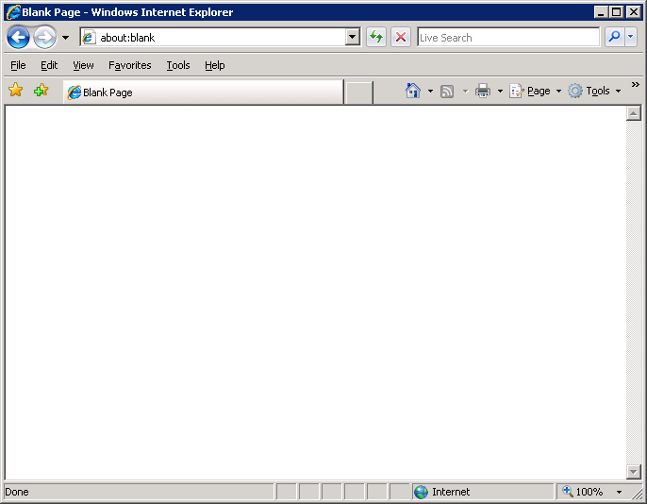

Connecting to the Registered Area

To connect the registered area write this in the address area :

http://www.vbsoftware.cl/jspad/regusers

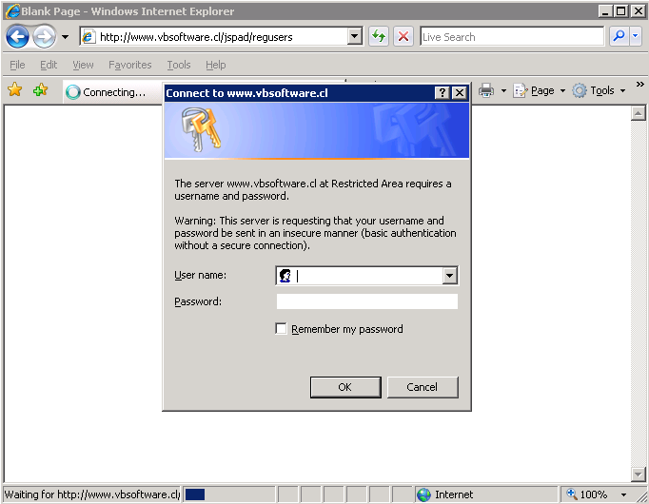

You will be prompted with a user name and password.

In the User Name textbox write the user name sent to you in the contact email.

In the Password textbox write the password sent to you in the contact email.

The next window will be display :

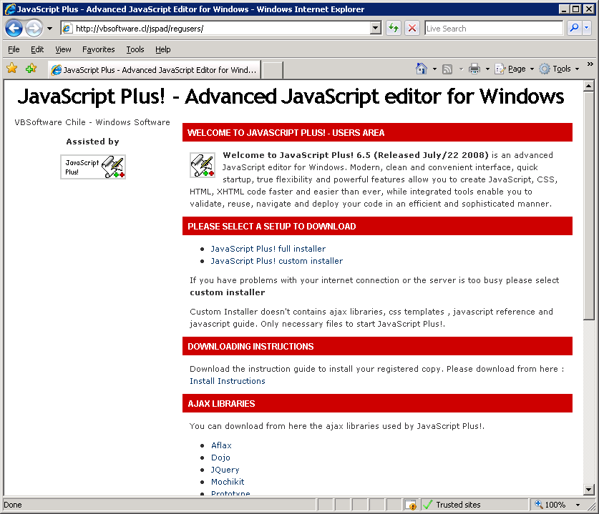

Clic on link “JavaScript Plus! Full installer” to start downloading the setup.exe file and save to your PC. If this window appear clic on the Save button.

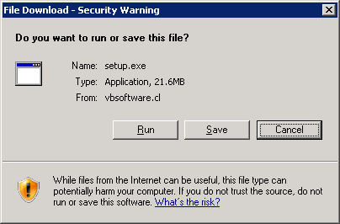

Clic on the Save button to save the file on your PC.

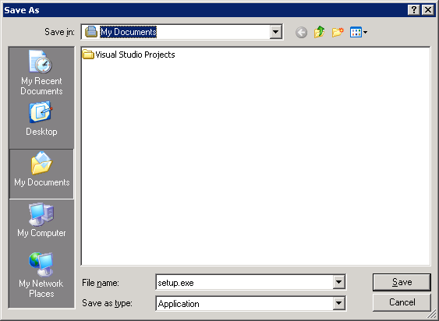

After you have clicked the Save button the next window appear :

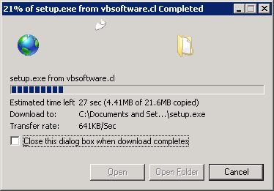

Problems downloading the setup.exe file ?

If you get a message about a corruption in the setup.exe is because you have problems downloading the file using your internet connection. Try until you can download without problems.

We only can help you building a special setup.exe without all necessary files. The setup.exe file include all files used by JavaScript Plus!. (CSS Templates, Ajax Libraries, JavaScript Help & Reference). This can take a little time building this special setups, but it’s possible installing all necessary files using customs setups.

Please contact me if you get this message downloading setup.exe. If you get another error downloding setup.exe please feel free to contact me.

Contacting VBSoftware Support

We are located in South America. It’s possible we have more or less hours the differences with your Country. Please keep on eye this tip.

Answer an email can take a little time. Please be patient.

Ordering or contacting Saturday or Sundays will be responded on the next week.
Installing JavaScript Plus!

Please follow the next steps to install your registered copy.

Starting the JavaScript Plus! Installer

To start the JavaScript Plus! installer double clic on the setup.exe file. If the next window is shown clic on the Run button.

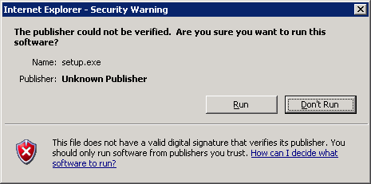
Welcome Screen

This is the “Welcome” screen.

Clic on the Next button to continue.

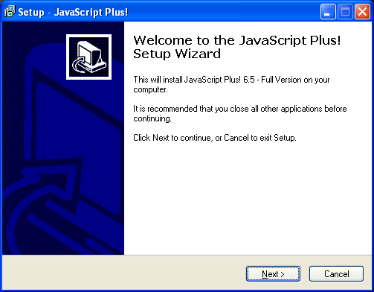
Step 1

License Agreement Screen

This is the “License Agreement” screen. Please read the license agreement. If you accept the license agreement clic on “I accept the agreement” option.

Clic on the Next button to continue.

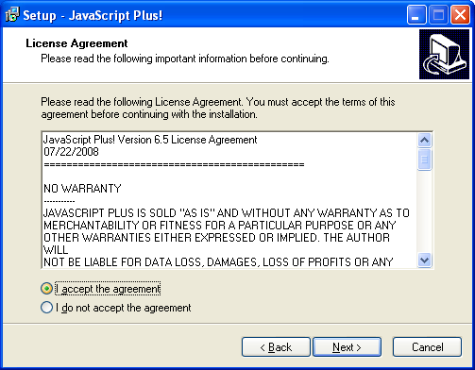
Step 2

Information Screen

This is the “Information” screen. This screen gives to you information about JavaScript Plus!.

Clic on the Next button to continue.

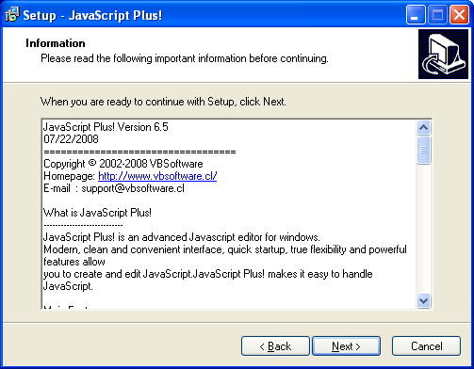
Step 3

Select Destination Location Screen

This is the “Select Destination Location Screen”. You must select or pick a folder where you will install your registered copy. Default option is “Program Files”. If you want to install using another folder clic on the “Browse” button.

After you have finished your selection clic on the Next button to continue.

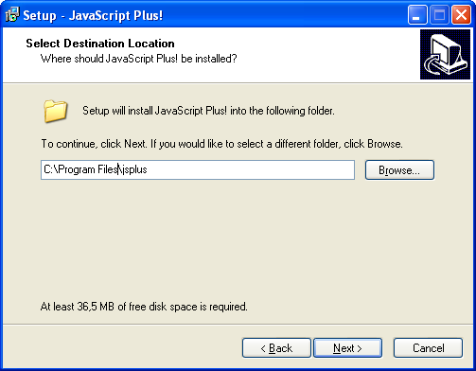
Step 4

Select Start Menu Folder Screen

This is the “Select Start Menu Folder” screen. You must select a “Windows Folder” where you place the shortcuts to JavaScript Plus!. Default option is “VBSoftware”. If you want to choose another folder clic on the Browse button.

Clic on the Next button to continue.

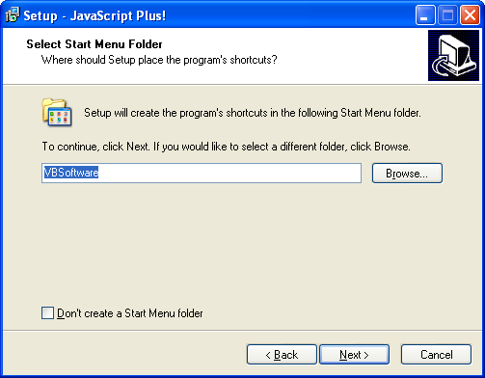
Step 5

Select Additional Tasks Screen

This is the “Select Additional Tasks Screen”. The “Create a desktop icon” will creates a shortcut to JavaScript Plus! In your desktop. The “Create a Quick Launch Icon” will creates a quick launch icon on the menu status bar.

Clic on the Next button to continue.

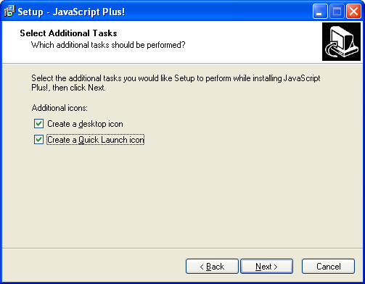
Step 6

Ready to Install Screen

This is the “Ready to Install” screen. If you are ready to install clic on the Install button. To cancel and exit without install clic on Cancel button. To change or modify any option clic on the Back button.

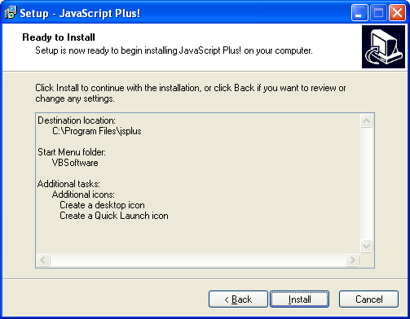
Step 7

Installing Screen

This is the “Installing” screen. Please wait until the installation process finish installing all files. If you want to cancel the installation clic on the “Cancel” button.

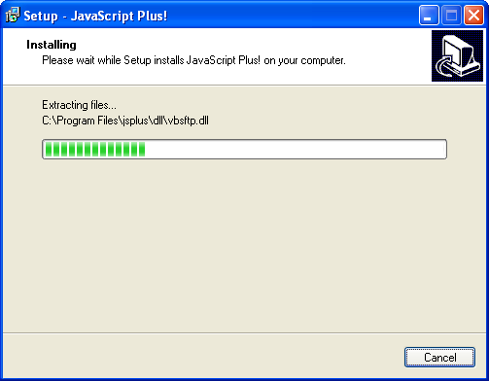
Step 8

Information Screen

This is the “Information” screen. This shows information about the last updates, bug fixed or improvements to JavaScript Plus!.

Clic on Next button to continue.

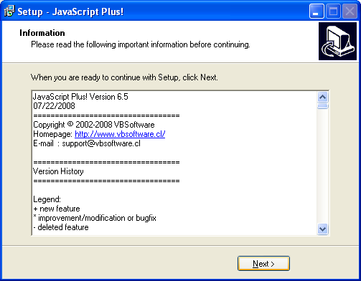
Step 9

Completing the JavaScript Plus! Screen

This is the “Completing the JavaScript Plus!” screen. Congratulations! You have installed your registered copy without problems.

Important : Before to clic on Finish button uncheck the “Launch jsplus” check button. If you check “Launch jsplus” your registered copy will not start because you need the reguser.ini file to start your registered copy.

To exit from installer clic on Finish button.

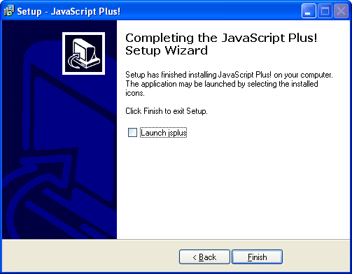
Step 10

Preparing to Start your Registered Copy

Now, you have installed your registered copy you need a file named reguser.ini. This file is read for JavaScript Plus! to start. If this file doesn’t exists inside the JavaScript Plus! folder your registered copy don’t start.

Please never delete, rename or remove your reguser.ini file. Without this file your registered copy don’t start.

The reguser.ini file

The reguser.ini file is the licensing file required to start JavaScript Plus!. The reguser.ini contents looks like this :

[user]
name=Value

The [user] is the .ini section to be read for JavaScript Plus!. The name= is the key where to locate the name. Value is the user name to display on About Box.

Example :

[user]
name=Your Name/Your Company

Creating the reguser.ini using Windows Notepad

To create the reguser.ini file using Windows Notepad follow the next steps :

From Start button choose run :

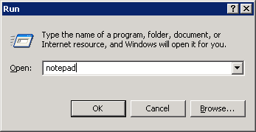

In the Open textbox write notepad. Press Ok button to continue.

If you have installed Windows Notepad a window like this appear :

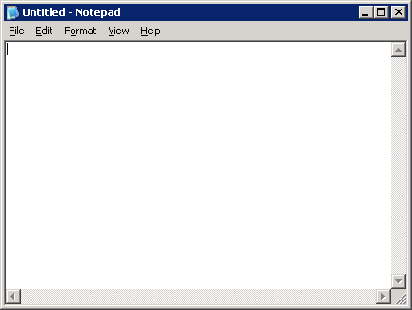

Inside the editor write the next contents :

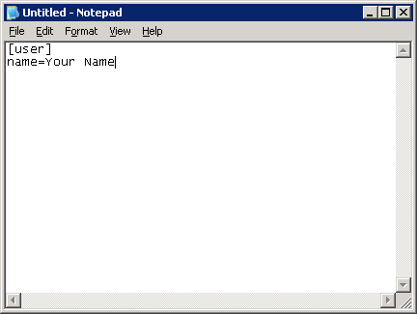

Where Your Name you must write your name or Company.
Clic on the File Menu and select the folder where you have installed JavaScript Plus!.

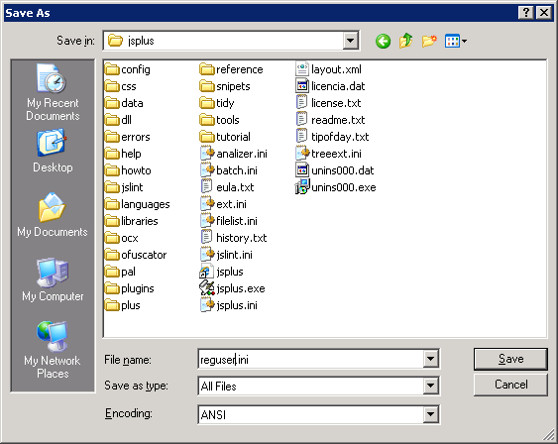

In the File Name textbox write reguser.ini

In the Save as type combobox select All Files.

Clic on Save button to write the file to disk.

Exit from Windows Notepad.

Starting your Registered Copy

Congratulations!, you are ready to start your registered copy. Start your registered copy from your Windows Desktop Shortcut or VBSoftware Windows Folder.

You must see the Welcome Window

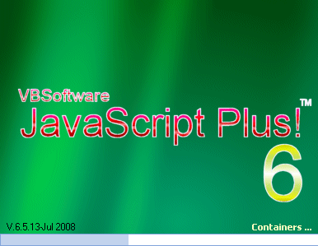

This finish the Quick Installation Guide. Please enjoy your registered copy.

Remember as registered user you get free of charge updates/upgrades. You only must send your RegNow Order Id. After the order will be validated will send to you an user and password to access the registered area.

Problems running your Registered Copy ?

If you start your registered copy and you see the this error window is because you have not configured or installed your reguser.ini file. Please read the section about how to create and install the reguser.ini file.

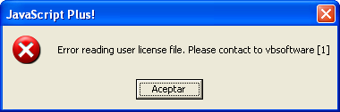

If you cannot start your registered copy please send email to contact@vbsoftware.cl

Others Reference

This software contains vbaccelerator controls, code and libraries. http://www.vbaccelerator.com

This software contains software found at PSC Planet Source Code. http://www.planet-source-code.com

This software uses tidy. http://tidy.sourceforge.net

This software uses jslint. http://www.jslint.com

This software uses templates from : http://www.freecsstemplates.org

